CMPT 354 Assignment 1

Junchen Li

301385486

2021/6/5

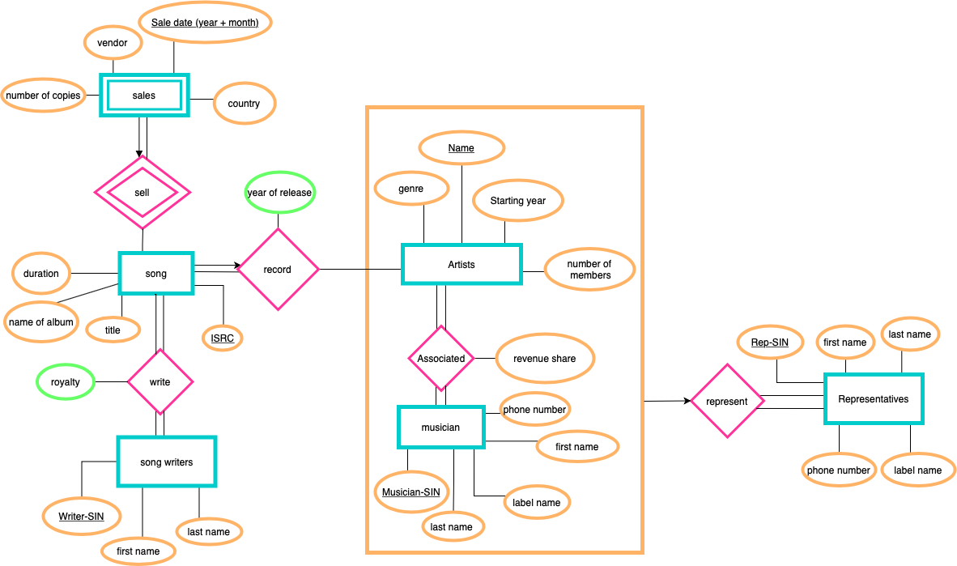

# This Entity Relationship Diagram made by https://app.diagrams.net

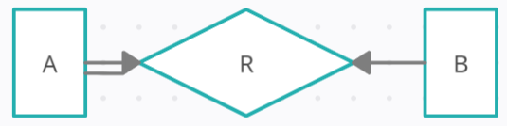2.

a)

B can be associated with at most one A

Every A must R by at least one B (total parti)

A can be associated with at most one B

|  |  |
| --- | --- |
| **A PK** | **B PK** |
| John | Toronto |
| Alice | Moscow |
| Zhang | Buenos Aires |
| Farah | Nairobi |

* All the entities in A are participate in R.
* There are entities from B that do not participate in R (Kuala Lumpur)
* Every entity in A can be associated with at most one entity in B
* Every entity in B can be associated with at most one entity in A

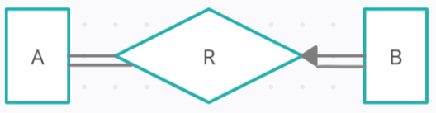

b)

Every b must R by at least one a

B only can be associated with one A

Every A must R by at least one B

|  |  |
| --- | --- |
| **A PK** | **B PK** |
| John | Toronto |
| Alice | Moscow |
| Zhang | Buenos Aires |
| Farah | Kuala Lumpur |
| John | Nairobi |

* All the entities in A are participate in R.
* All the entities in B are participate in R.
* Some entities from A participate in more than one relationship (John)
* Every entity in B can be associated with at most one entity in A

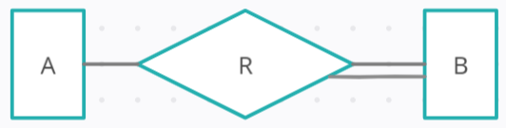c)

Every B must R by at least one A

A can be associated with any number of B (No constraint relation)

|  |  |
| --- | --- |
| **A PK** | **B PK** |
| John | Toronto |
| Alice | Moscow |
| Zhang | Buenos Aires |
| Zhang | Kuala Lumpur |
| Alice | Nairobi |
| John | Toronto |

* There are entities from A that do not participate in R (Farah)
* All the entities in B are participate in R.
* Some entities from A participate in more than one relationship (John, Alice, Zhang)
* Some entities from B participate in more than one relationship (Toronto)